USB FORENSICS TOOL
PROJECT REPORT
Comprehensive Technical Documentation and Runtime Analysis

Repository: USB-Forensics-Tool-first
Branch: ReportAndPaper
Report Generated (UTC): 2026-03-26T09:37:42.189117+00:00
Platform: Windows
Language: Python 3.13

TABLE OF CONTENTS
- Abstract
- Chapter 1: Introduction
- Chapter 2: Technical Background and Related Concepts
- Chapter 3: Methodology and Processing Pipeline
- Chapter 4: Module-by-Module System Design
- Chapter 5: Runtime Execution, Screenshots, and Results
- Chapter 6: Security, Limitations, and Future Enhancements
- Conclusion
- References

ABSTRACT
The USB Forensics Tool is a Python-based digital forensics platform that performs endpoint-level USB artifact analysis through a combination of device enumeration, Windows telemetry processing, anomaly scoring, optional USB trace intelligence, and multi-format reporting. The project supports both a professional Tkinter GUI workflow and script-driven processing for evidence generation. Its architecture is modular and designed for graceful degradation: when privileged Windows APIs or optional packages are unavailable, the system continues in reduced mode with fallback logic. This report documents the complete technical stack, internal methods, algorithms, module responsibilities, runtime behavior, generated evidence artifacts, and practical limitations.

CHAPTER 1: INTRODUCTION
USB media and removable peripherals are frequent vectors in enterprise and personal device incidents. This project was developed as an end-to-end forensic toolkit to discover USB-connected hardware, reconstruct activity timelines, score anomalies, and export investigation-ready reports.
The solution targets Windows environments where registry hives, event logs, and USB stack telemetry provide high forensic value. The GUI design emphasizes analyst productivity through page-based workflows: Devices, Storage, Timeline, Analysis, URB Capture, Security, and Export.

CHAPTER 2: TECHNICAL BACKGROUND AND RELATED CONCEPTS
The architecture combines host artifact analysis (registry and event logs) with optional deep packet/trace telemetry. A key design choice is graceful degradation: the tool should remain runnable and demonstrable even when pywin32, admin privileges, or trace tooling are unavailable.
Layer | Technologies | Purpose
Language and Runtime | Python 3.13 | Primary implementation language
GUI | Tkinter, ttk | Professional desktop interface and workflows
Windows Integration | pywin32, WMI, winreg, win32evtlog | USB device and event acquisition
Report Export | csv, json, openpyxl, reportlab | CSV, JSON, XLSX, and PDF outputs
Image and Media | Pillow (ImageGrab) | GUI screenshots and visual evidence support
Trace Analytics | Wireshark/tshark JSON bridge | Optional packet-level USB behavior analysis
URB Capture | ETW, logman, etl-parser | USB Request Block capture and parsing
Extensions | JSON IPI bridge + pluggable modules | Recall, firmware validation, AI narrative extensions

CHAPTER 3: METHODOLOGY AND PROCESSING PIPELINE
- Step 1 - Device acquisition: collect USB hardware entities via WMI, then PowerShell fallback, then mock fallback.
- Step 2 - Artifact collection: parse USBSTOR registry keys and relevant Event Log IDs for connection behavior.
- Step 3 - Correlation: merge multiple artifact streams into unified DeviceRecord timelines.
- Step 4 - Enrichment: derive storage, folder, deleted-file, and reputation analysis per device.
- Step 5 - Scoring: compute anomaly score (0-100) using serial presence, volume of events, storage pressure, and optional trace indicators.
- Step 6 - Reporting: export enriched findings to CSV, JSON, XLSX, PDF, and detailed JSON.
- Step 7 - Optional deep analysis: parse tshark JSON/pcap-derived capture and ETW URB traces for suspicious communication signatures.

CHAPTER 4: MODULE-BY-MODULE SYSTEM DESIGN

MODULE RESPONSIBILITY MATRIX
Module | Primary Methods | Responsibility
core/usb_device_manager.py | get_all_usb_devices, classify_device_type, extract_vid_pid | Enumerate and classify USB devices using WMI or PowerShell fallback
core/registry_parser.py | parse_registry | Acquire USB registry artifacts from USBSTOR with fallback entries
core/eventlog_parser.py | parse_event_logs | Acquire connect/disconnect events from Windows Event Log
core/correlation.py | correlate | Unify registry and event sources into DeviceRecord timelines
core/analysis.py | enrich_summary, compute_anomaly_score, detect_suspicious | Compute forensic metrics, scoring, and suspicious flags
utils/report_generator.py | write_csv, write_json, write_xlsx, write_pdf | Generate formal forensic outputs in multiple formats
core/wireshark_bridge.py | load_capture, runtime_info | Load and parse tshark JSON for USB trace packets
core/usb_trace_analysis.py | analyze_usb_trace, match_trace_report | Detect suspicious communication patterns in packet-level traces
core/urb_capture.py | parse_etl_file, URBCapture | Capture and parse ETW URB operations for low-level USB telemetry
extensions/bridge.py | IPIBridge, BaseToolExtensionInterface | Route JSON messages to extension modules without core edits

CHAPTER 5: RUNTIME EXECUTION, SCREENSHOTS, AND RESULTS
The application was executed on Windows, and screenshots were captured programmatically from live GUI windows. The runtime evidence pipeline generated new report files (CSV/JSON/XLSX/PDF/detailed JSON) and captured the current USB device state.
Metric | Value
Runtime Timestamp (UTC) | 20260326T093628Z
Detected Devices | 10
Suspicious Devices | 0

RUNTIME DEVICE SNAPSHOT
Name | Type | VID:PID | Serial | Anomaly
USB Input Device | input | 062A:4101 |  | 25.0
Realtek Bluetooth Adapter | network | 0BDA:4853 | 00E04C000001 | 0.0
UCM-UCSI ACPI Device | unknown | : | 0 | 0.0
USB Root Hub (USB 3.0) | hub | : |  | 25.0
Goodix fingerprint | printer | 27C6:550A |  | 25.0
AMD USB 3.10 eXtensible Host Controller - 1.10 (Microsoft) | unknown | : |  | 25.0
Integrated Camera | audio_video | 04F2:B7BA |  | 25.0
USB Composite Device | hub | 062A:4101 |  | 25.0
USB Composite Device | hub | 04F2:B7BA | 0001 | 0.0
USB Input Device | input | 062A:4101 |  | 25.0

EXECUTION SCREENSHOTS
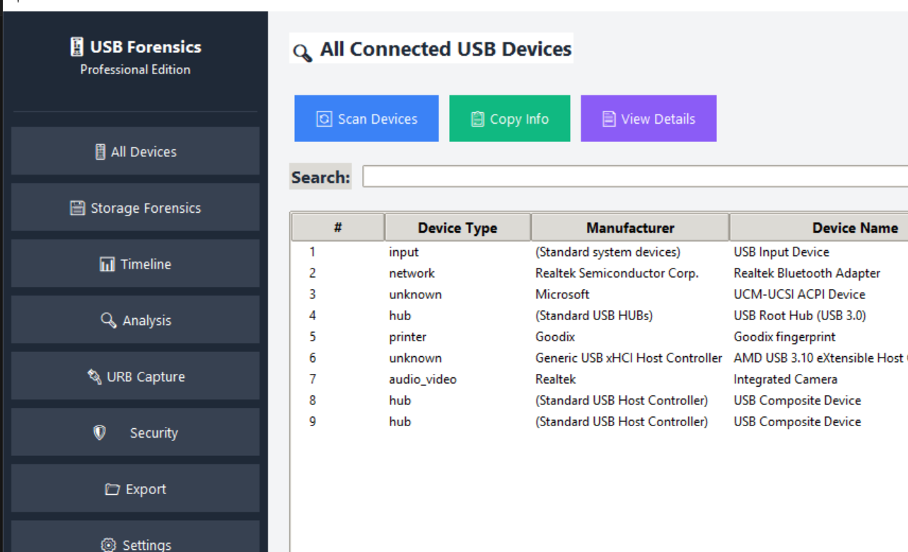
Figure 1: All Connected USB Devices page after runtime scan.
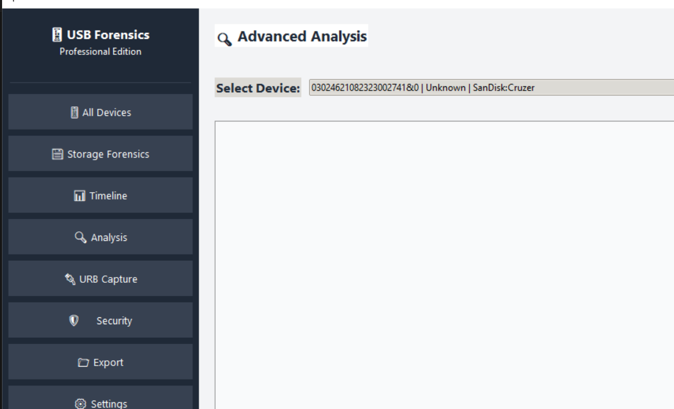
Figure 2: Advanced Analysis page showing selected USB device context.
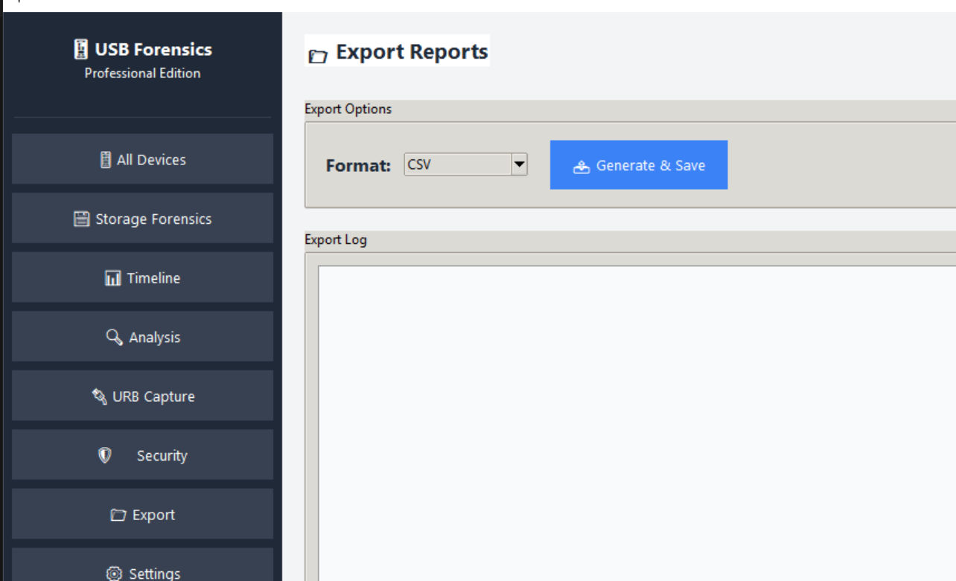
Figure 3: Export Reports page with format selection and export action.

GENERATED EVIDENCE ARTIFACTS
- csv: E:\Revanth\USB-Forensics\USB-Forensics-Tool-first\report and paper\runtime_evidence\20260326T093628Z\forensics_report_20260326T093628Z.csv
- json: E:\Revanth\USB-Forensics\USB-Forensics-Tool-first\report and paper\runtime_evidence\20260326T093628Z\forensics_report_20260326T093628Z.json
- xlsx: E:\Revanth\USB-Forensics\USB-Forensics-Tool-first\report and paper\runtime_evidence\20260326T093628Z\forensics_report_20260326T093628Z.xlsx
- pdf: E:\Revanth\USB-Forensics\USB-Forensics-Tool-first\report and paper\runtime_evidence\20260326T093628Z\forensics_report_20260326T093628Z.pdf
- detailed_json: E:\Revanth\USB-Forensics\USB-Forensics-Tool-first\report and paper\runtime_evidence\20260326T093628Z\forensics_detailed_20260326T093628Z.json

CHAPTER 6: SECURITY, LIMITATIONS, AND FUTURE ENHANCEMENTS
Current security strengths:
- Cross-source evidence collection (registry plus event timeline plus optional traces).
- Heuristic suspicious pattern detection and anomaly scoring.
- Optional packet-level behavioral analytics for identifying potential BadUSB style indicators.
- Pluggable extension framework for recall, firmware, and AI-assisted narrative analysis.
Current limitations:
- Many advanced features require administrator privileges and Windows APIs.
- Some enrichment sections depend on external or simulated data sources.
- Scoring is heuristic-based and should complement, not replace, analyst judgment.
- Trace and URB analyses are optional and depend on capture availability and tooling readiness.
Recommended future work:
- Add cryptographic evidence chaining and tamper-evident audit logs.
- Introduce signed plugin loading and extension permission controls.
- Expand model-driven anomaly scoring using historical baselines.
- Automate timeline visualization and case-oriented report templates.

CONCLUSION
The USB Forensics Tool provides a practical and extensible forensic platform for investigators who need rapid USB visibility with optional deep protocol inspection. Its modular architecture, fallback-safe implementation, and strong reporting support make it suitable for academic demonstration as well as controlled operational workflows.

REFERENCES
- Project repository source files: main.py, gui/app.py, core/*.py, utils/report_generator.py
- Windows Event Log and Registry artifacts relevant to USB forensic reconstruction
- Wireshark/tshark documentation for USB capture parsing
- Python package documentation: pywin32, openpyxl, reportlab, Pillow, python-docx

